

**Lab 3: LCD UART IDLP**

**CECS 347**

**Kenny Khut, Kuldeep Gohil**

**October 16, 2019**

**Lab Description:**

The purpose of this lab is to use UART to control the brightness and color of the LED on the Launchpad board and display the color and brightness on a ST7735 color display. The lab uses the two times from the previous lab to control the brightness of the LED through a pulse. Using UART, we send a signal to the launchpad and the board controls the color and brightness of the LED based on the signal it receives. Brightness is controlled by inputting a number between 0-5, and color is controlled by inputting r, g, b for red, green, or blue. The board will send signal to the ST7735 color display to display the color and brightness of the LED. This is represented by a bar that is the same color as the LED and length represents the brightness of the LED. The position of the bar is also determined by what color the LED is.

**Schematic:**

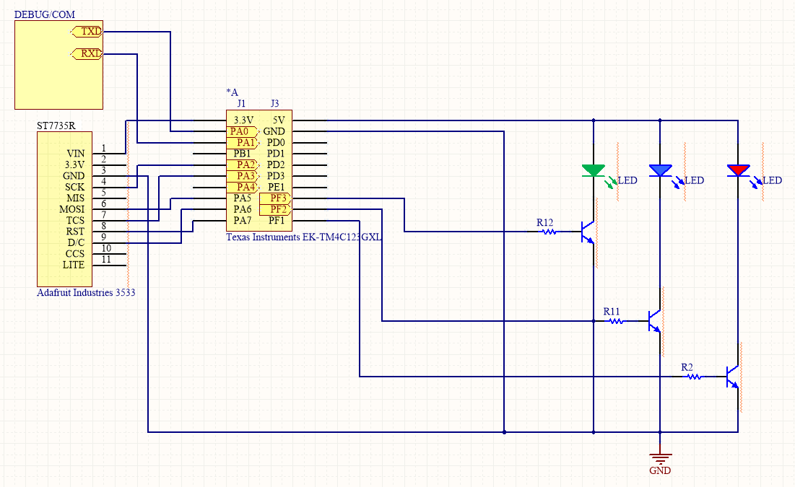

**C source code:**

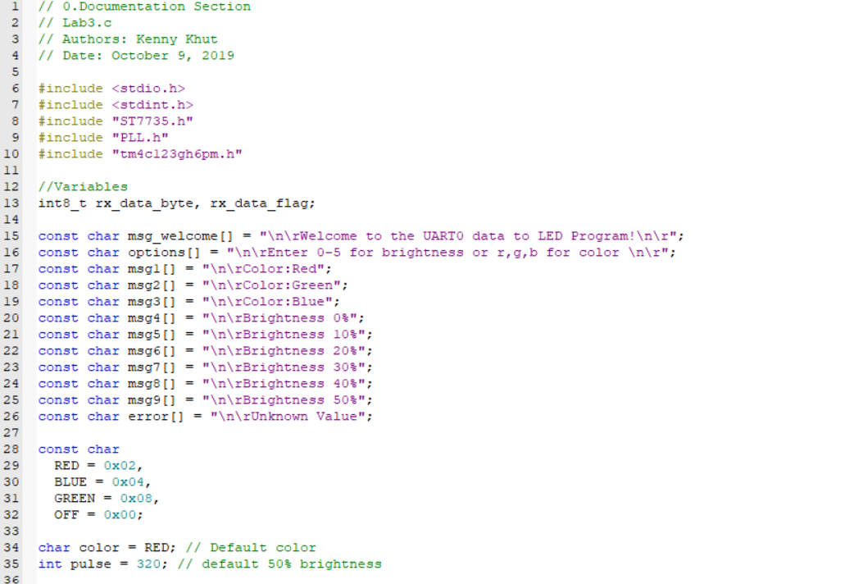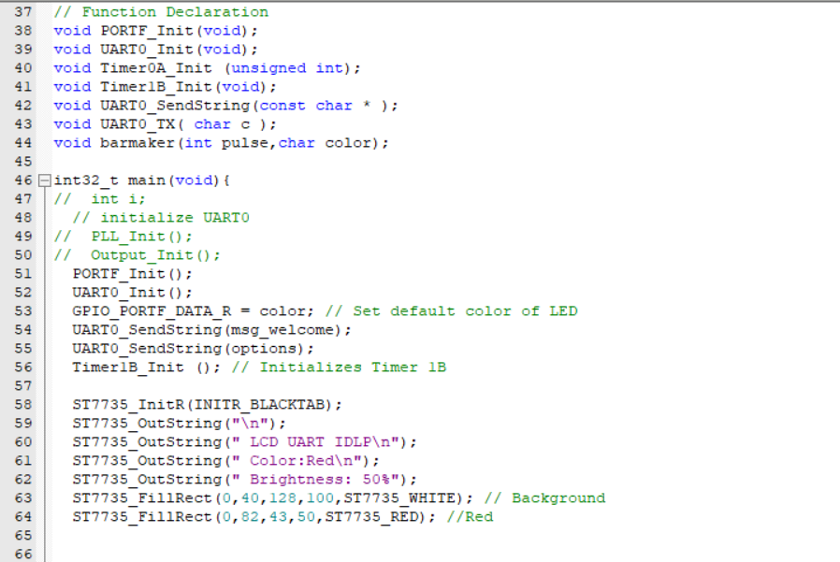

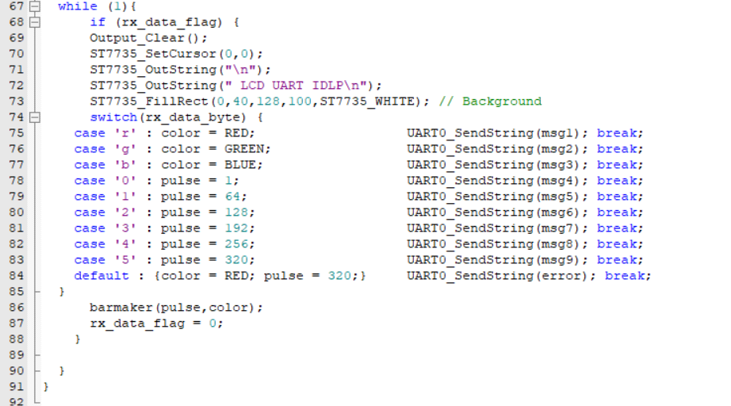

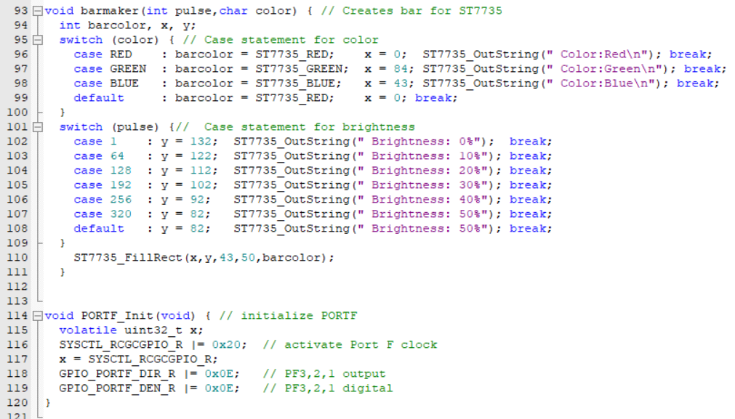

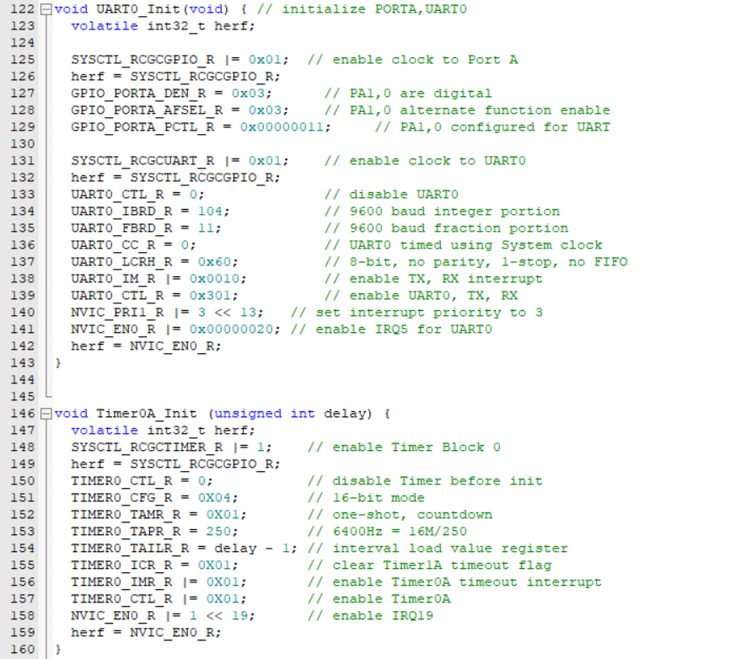

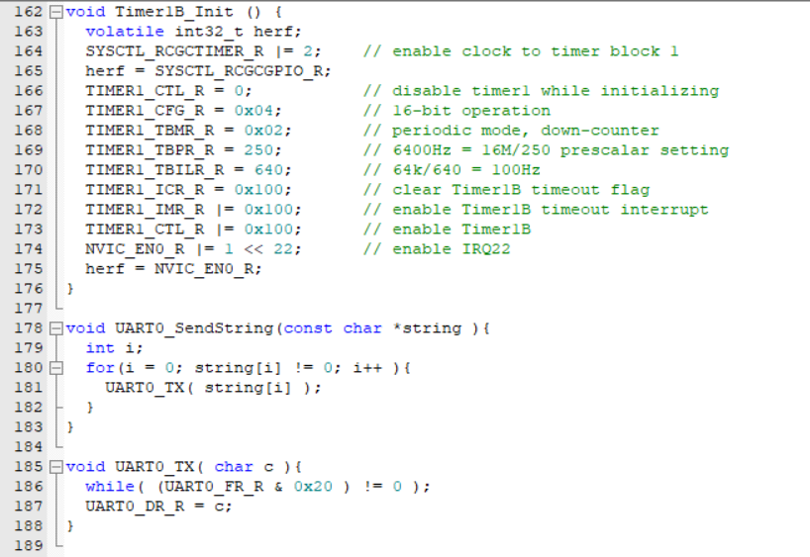

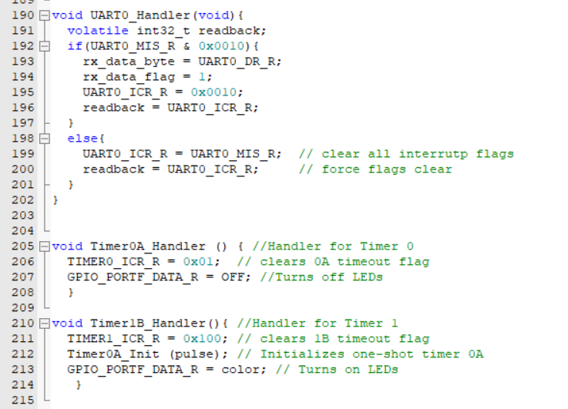

**Conclusion:**

In conclusion, this lab used aspects of the last lab dealing with the UART menu and utilized an LCD screen as the output. An LCD is a great way to visualize the output and simplify the program for anyone to use. We passed inputs of the program through UART on the computer and that was passed through the TM4C123GXL board which was connected to the LCD screen to display the output. We learned of two types of outputs, which included color and text. With the knowledge of LCD screen and the functionality with TM4C123GXL board, we now will be able to improve our future demonstrations and visually show the workings of our labs.